Docker Assignment-1

Create 3 branches under git repo 2026Q1, 2026Q2, 2026Q3 and add index.html files to it. Run a pipeline job on Jenkins master where Q1 container needs to be created and deploy 2026Q1 index file, Q2 container needs to be created and deploy 2026Q2 index file and Q3 container needs to be created and deploy 2026Q3 index file.

- Launch Jenkins master
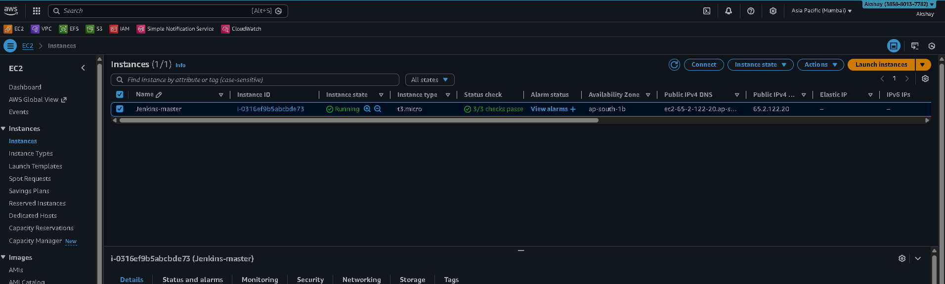

- Github branches
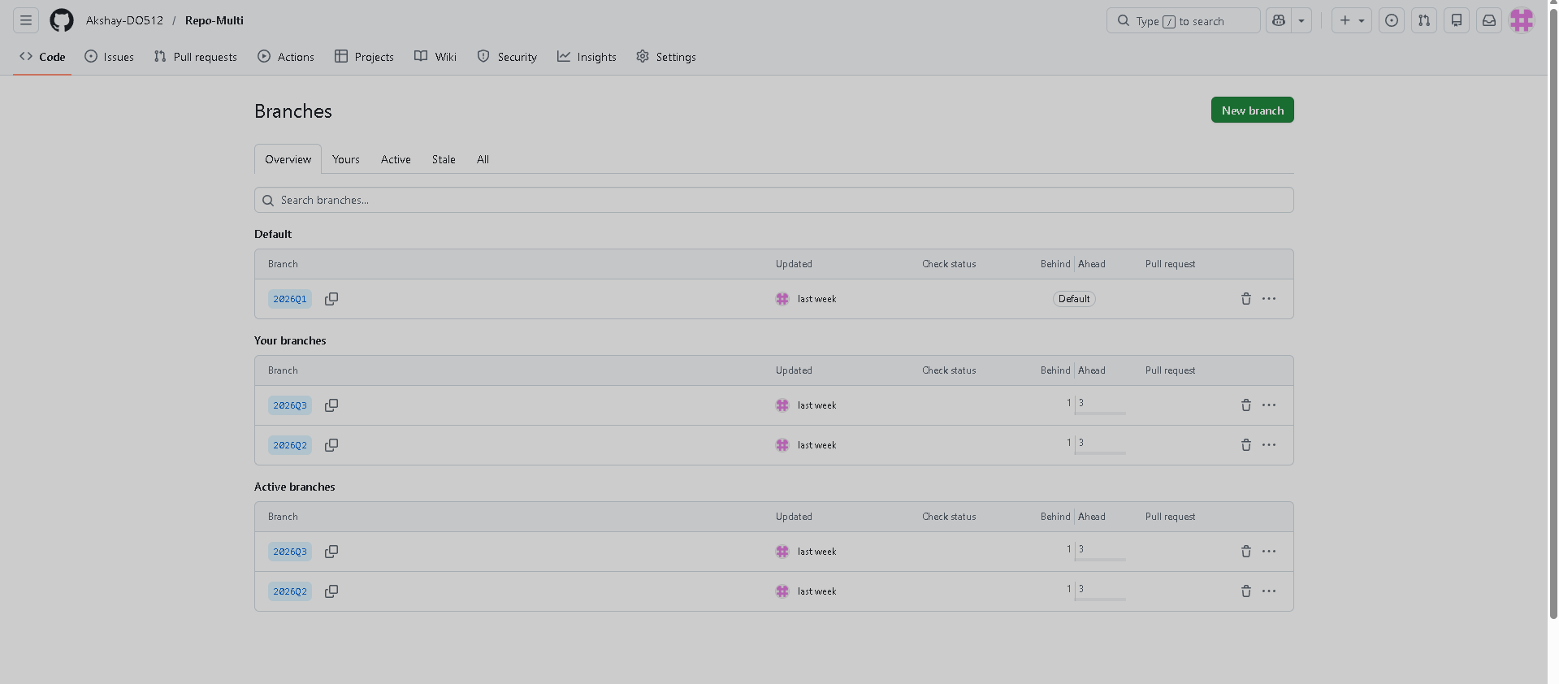

- Jenkins Job
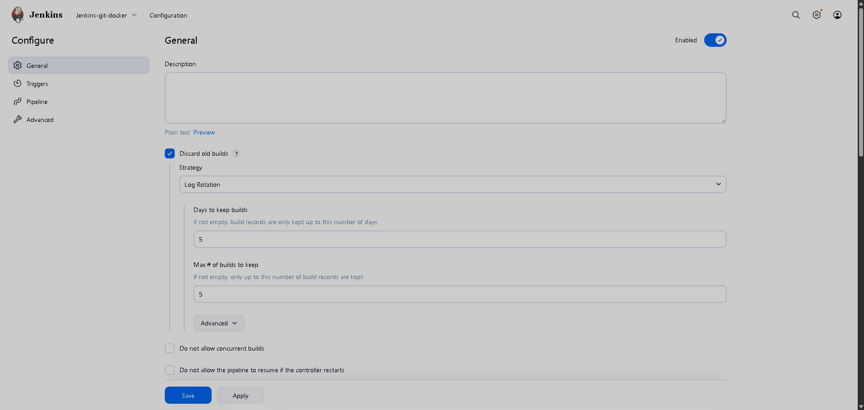
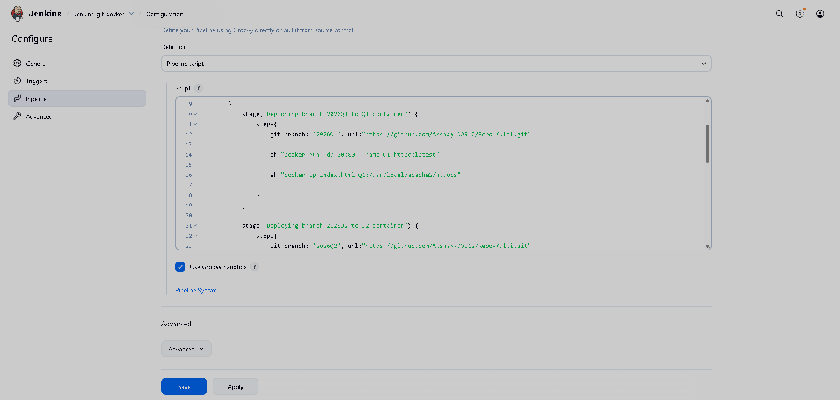
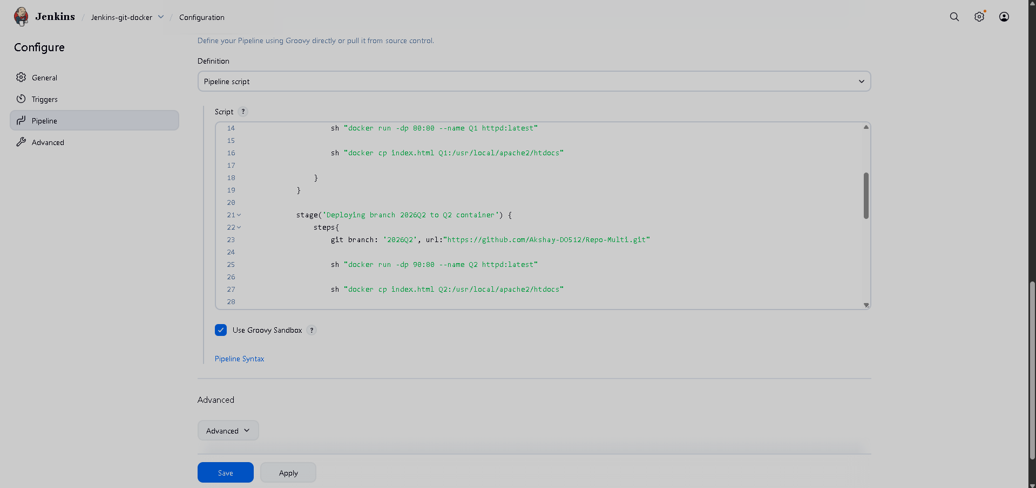
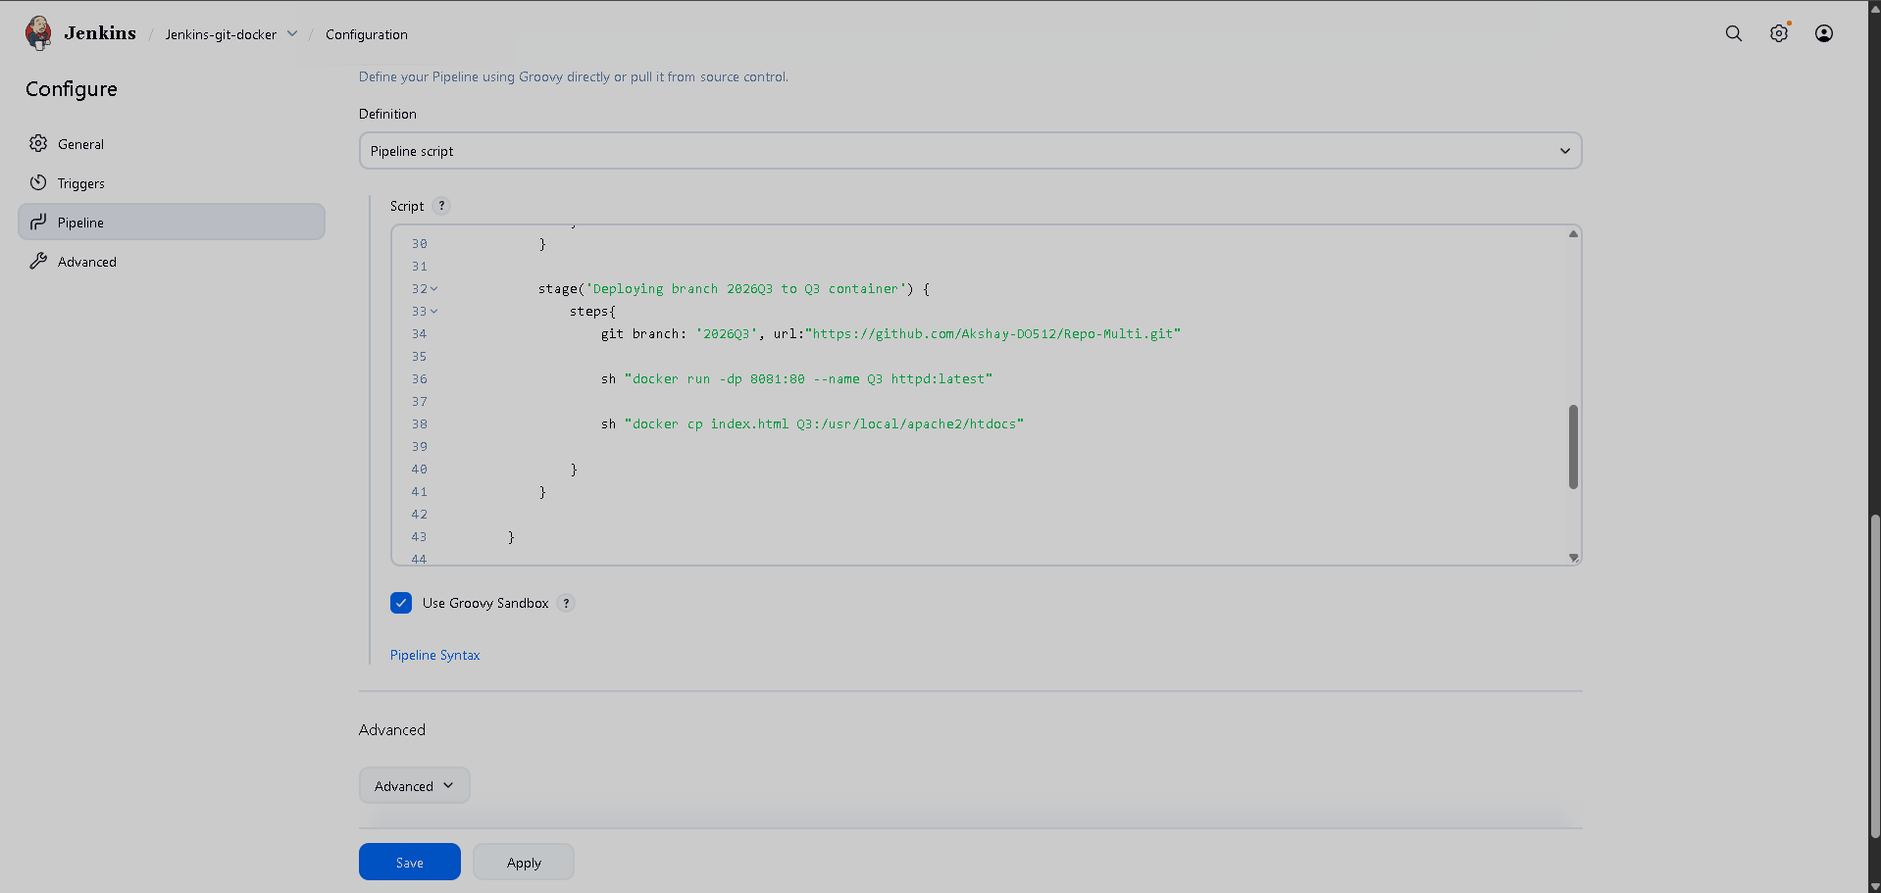
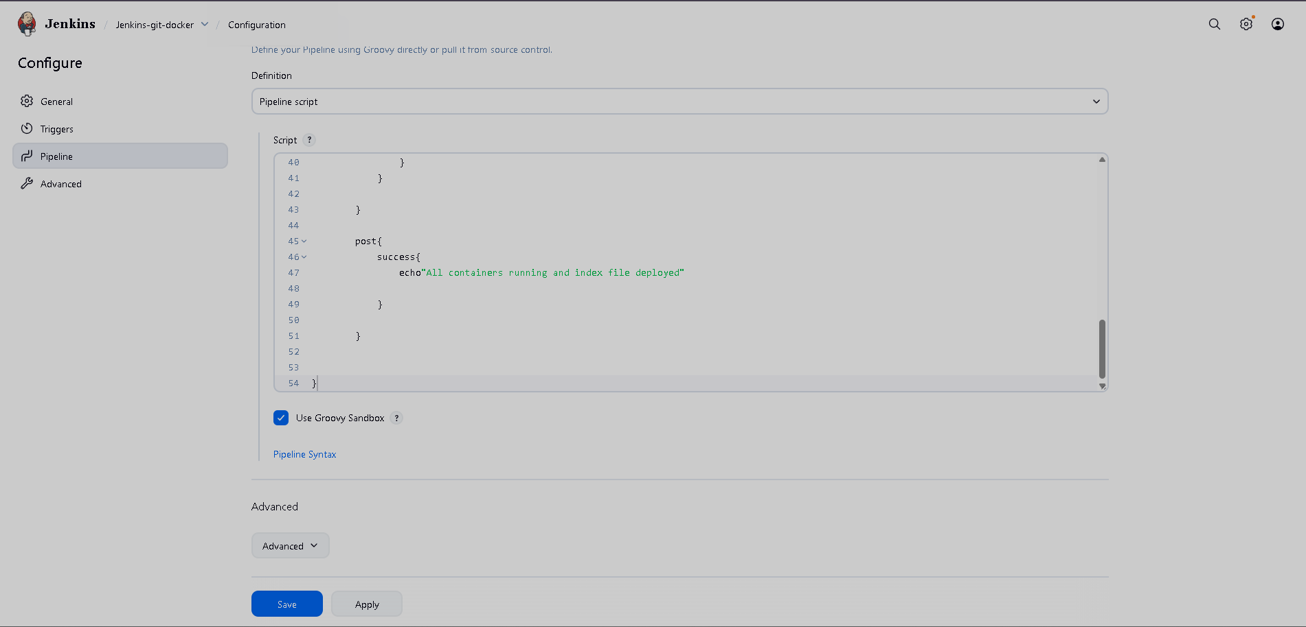

Output:
Port 80
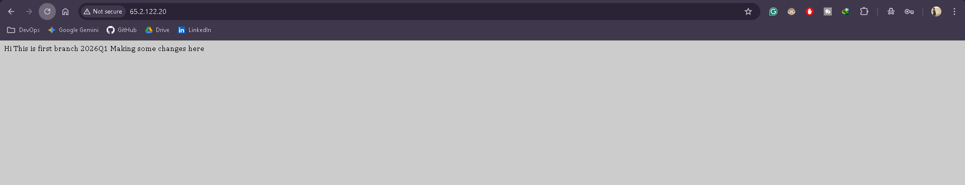

Port 90
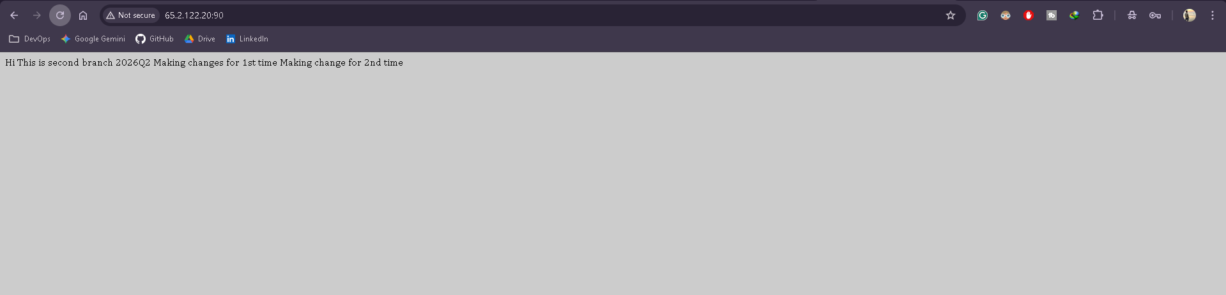

Port 8081
